Safety Insights form

Danelec Service Partners
The onshore solution Danelec Safety Insights requires a Danelec VRS installed and connected to a Danelec VDR. A limitation is often internet access from the vessel and Vessel IT must provide this information. The form may help with the Vessel IT department ahead of installation to get the needed information to complete installation.

Vessel (Action)
The vessel that should be installed.

Vessel
Name: | Splendid-Tenacia-Rhapsody
IMO:

Purpose (Info)
The below information (section 2) is for your convenience to communicate with the Vessel IT and take the information to the installation. Below simplified installation drawing shows what needs to be known and arranged before the installation.

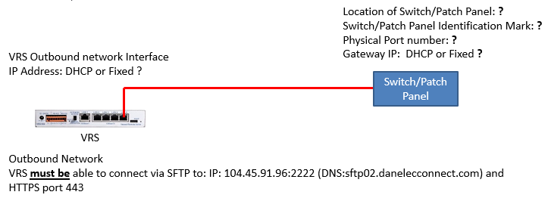

Vessel IT

Verify outbound communications (Action)
Ensure communication to shore can be established at the time of the installation.

Outbound Communications
HTTPS (TCP/443) | https://global.azure-devices-provisioning.net
 | https://danelec-control.azure-devices.net
 | https://api.danelec-marine.com
SFTP (TCP/2222) | 104.45.91.96:2222
 | sftp02.danelecconnect.com:2222

DNS or IP (Action)

Danelec VRS IP address setup
The Danelec equipment is preconfigured for a setup view DCHP, and no further actions are needed and go to section 2.3 Pre–installation information (action).
If the IP assignment uses DHCP go to section 2.2.2, Gateway IP configuration, or write the VRS IP address below:

Danelec VRS IP address
IP Address | 172.31.10.249
Subnet mask | 255.255.255.248

Gateway IP configuration

If the Gateway IP address is provided by DHCP go to section 2.2.3, DNS configuration, or write the Gateway IP address below:
Outbound Gateway IP Address
IP Address: | 172.31.10.254

DNS configuration

DNS (One DNS address is mandatory)
Static DNS Server 1: | 8.8.8.8
Static DNS Server 2: | 8.8.4.4
If the DNS IP address is provided by DHCP no further actions is need, otherwise write the Static DNS server IPs below:

Pre–installation information (action)
Physical outbound connection for VRS
Location of switch/patch panel: | TBD – for each vessel
Identification and brand/model of switch/patch panel: | TBD – for each vessel
Port on switch/patch panel for VRS to be plugged in to (Please provide a fixed port number): | TBD – for each vessel

IT Vessel Contact (action)
Vessel IT responsible
(IT responsible must be available during installation for online troubleshooting)
Name:
Email:
Phone:

IT Vessel Confirmation (action)

All above IT settings are implemented.

Checklist | Yes | No
The above outbound communication has been verified | [ ] | [ ]
The above IP addresses are correct (ignore if DHCP) | [ ] | [ ]

If there at least one “No” above the situation will be corrected by <insert date>.

Send the completed checklist to the Danelec service partner.

